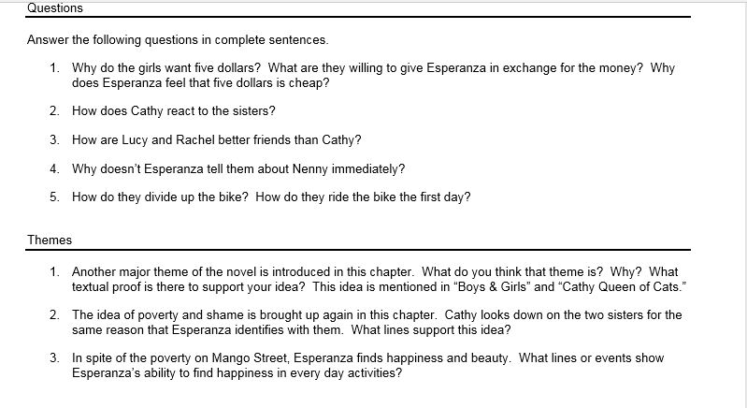
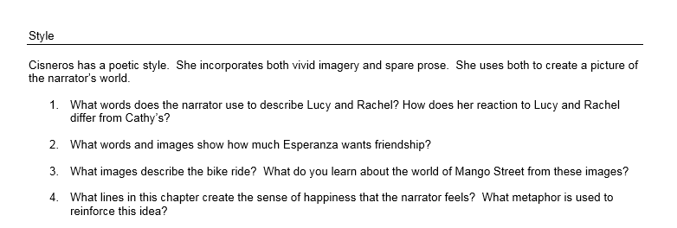

*Do the following questions:
1, 3 and 4
Themes: 2 and 3
Style: 3 and 4

