The Monkey Garden:
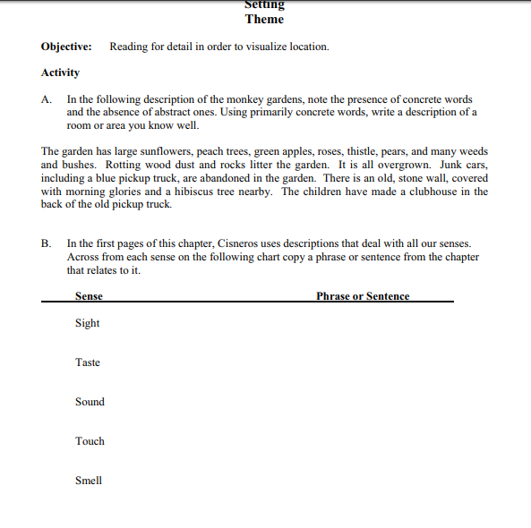

Sally, What Sally Said, Monkey Garden, Linoleum Roses:
