Name: ______________________________________ pd. ______
Fahrenheit 451 Character Analysis
Objective: Show how a key character in F451 has developed/ changed throughout the story through a narrative task or character analysis.

Choose one of the prompts below and circle it:
- Narrative- Continue the story: From this character’s point of view, create the next part of the story after the last time the reader has information about them in the book. All details from past parts of the story must be the same and the narrative should show the character’s personality and attitude towards other characters. Demonstrate that you are familiar with this character’s internal and external conflicts and how they view larger themes of the story. Must be one typed page long (size 14, 1 inch margins).

- Character analysis: Create a character analysis that shows the development of your character through F451. Discuss the character’s internal/ external conflicts and how they view larger themes of the story. Should have an intro, at least 3 body paragraphs and a conclusion.

Your Fakebook profile for your character will become a graphic organizer that provides text evidence/ structure for your paper.

When reviewing your evidence, consider:
Narrative: Character Analysis:
How does this quote show who my character is? What does this quote show about my character?

Each paper type: How does this quote connect my character with major themes of the book?

Grades will be holistic based on the rubrics of the next page. Paper must contain details that are accurate to the text and direct text evidence that focuses on conflict and theme.

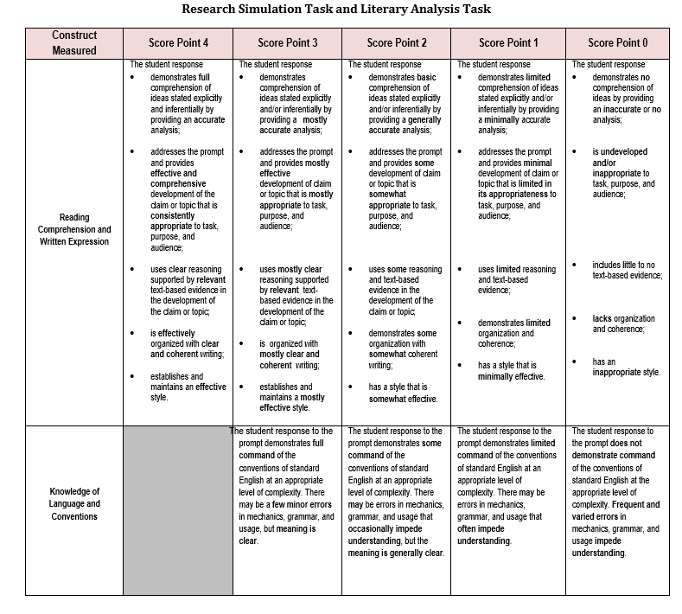
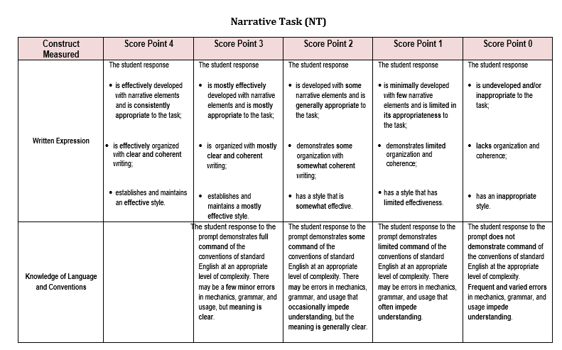

Fahrenheit 451 Character Analysis Notes
In order to write about characters, we need to be able to show how they handle their conflicts and how they connect with the theme of the story. Fill out these notes as we work on them in class.
Themes:
Topic: ____________________________________
Theme statement: ____________________________________________________________________________________________________________________________________________________________________________________________________

Topic: ____________________________________
Theme statement: ____________________________________________________________________________________________________________________________________________________________________________________________________

Topic: ____________________________________
Theme statement: ____________________________________________________________________________________________________________________________________________________________________________________________________

Conflicts: Man vs. (self, man, technology, society, nature, etc.)

Internal: _________________ vs. self:
____________________________________________________________________________________________________________________________________________________________________________________________________

External: _____________________ vs. _________________________
____________________________________________________________________________________________________________________________________________________________________________________________________

External: _____________________ vs. _________________________
____________________________________________________________________________________________________________________________________________________________________________________________________

Name: ________________________________________ pd._____
Character Analysis Quote Evaluation
Objective: Evaluate quotes that can be added to character analysis writing. Use the questions below to help guide you based on which writing option you choose to do.

- Narrative:
  - Are you writing 1st or 3rd person? How can your quotes be incorporated?
  - What direct quotes can your character reflect on/ recall?
  - What parts of the F 451 society will this character focus on?
- Analysis:
  - Thesis- Does the character change? How?
  - What direct quotes show the development of your character?
  - How are themes connecting with this character?
Fill out the chart using your Character Analysis notes from Friday (3/29) to help connect your quotes to conflict or theme.
Quote: | Theme topic or conflict: | How the quote connects to the theme or conflict: (2-3 sentences)
Do you know why books such as this are so important? Because they have quality. And what does the word quality mean? To me it means texture. This book has pores. -Faber | Theme topic- Knowledge vs. Ignorance, free thought | This quote is when Faber explains to Montag why books are important to society. It shows the importance of seeking knowledge from books. The first step is to find books with quality that make one think outside of their own experiences.

