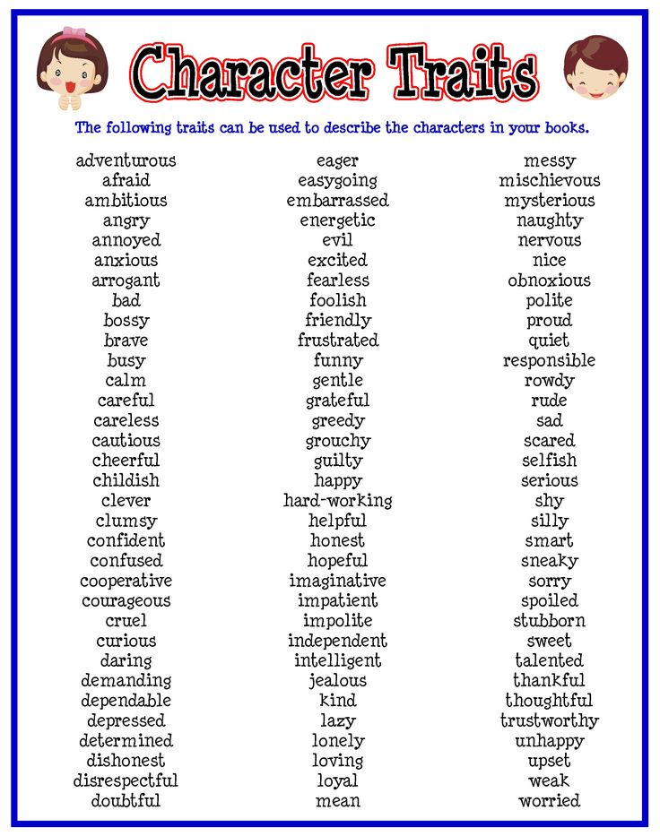
Identify 2 character traits for Mr. Nuttel and 1 character trait for Vera. Provide evidence in the form of actions/ words in "The Open Window."
Character | Character Trait | Actions/ Words in Story
Framton Nuttel

Framton Nuttel

Vera

